Institute of Systems Science
National University of Singapore

MASTER OF TECHNOLOGY IN
SOFTWARE ENGINEERING

Unit 3 Examination

Subject: Object Oriented Analysis and Design

Sample Examination Questions

Question 1 (refer also to Appendix A) (Total: 30 Marks)

Appendix A presents the specification for the Beijing Banking Corporation Customer Management Subsystem (CMS). It contains a summary of the required system functions, a use case model and use case descriptions.

You are required to undertake the Analysis for the CMS by answering the following questions:

a. Draw at least one Collaboration Diagram for each of the following use cases:

- Creating Customer
- Searching/Displaying Customer
- Perform Qualification

Note1: It will only be necessary to present user interface objects to the level of dialogue box and window (ie: no need to include interface objects representing buttons, list boxes, text fields etc).

Note2: You should represent the various databases as Actors, and show in your diagrams how your objects interact with these Actors.

Note3: Your diagrams should include both Standard Flow and Exceptions requirements.
(15 Marks)

b. Write the Flow of Events [as usually documented in the Standard Flow section of Use Realization Report (Analysis) document] for each of the following use cases:

- Creating Customer
- Perform Qualification

Note5: Each flow of events MUST include references to all relevant analysis objects and their operations.

Note6: It is recommended that you present your descriptions in note form.
(15 Marks)
Question 2 (refer also to Appendix B) (Total: 25 Marks)

Appendix B presents the requirement for the Phoenix Radio Management System. It contains a summary of the main system functions required by the radio station.

It is intended that this system should be developed using the RUP methodology. You are required to undertake the Requirements phase of the life cycle by answering the following questions:

- Draw one or more Use Case Diagrams to present the Use Case Model Global View for the system (Note: to simplify your model, you should represent add, modify and delete functions as one combined use case, rather than three separate use cases).
(15 Marks)

- Draw one or more Class Diagrams to present the Domain Object Model of the system (Note: it is not necessary to draw a diagram for each use case – system-wide diagrams are sufficient. In drawing your model, you can ignore user interface objects).
(10 Marks)

Question 3 (Total: 14 Marks)

Based on the use case description presented overleaf, answer the following questions:
- Complete the Billing and Collection use case description by adding the Exceptions and/or Alternate flow of events. You need only consider the critical exceptions associated with this use case.
(4 Marks)
- Identify the sequence of steps that comprise functional system test cases for this use case.
(6 Marks)
- An inexperienced analyst has drawn the collaboration diagram below for the Billing and Collection use case. What deficiencies can you detect in this diagram? Justify your answer.
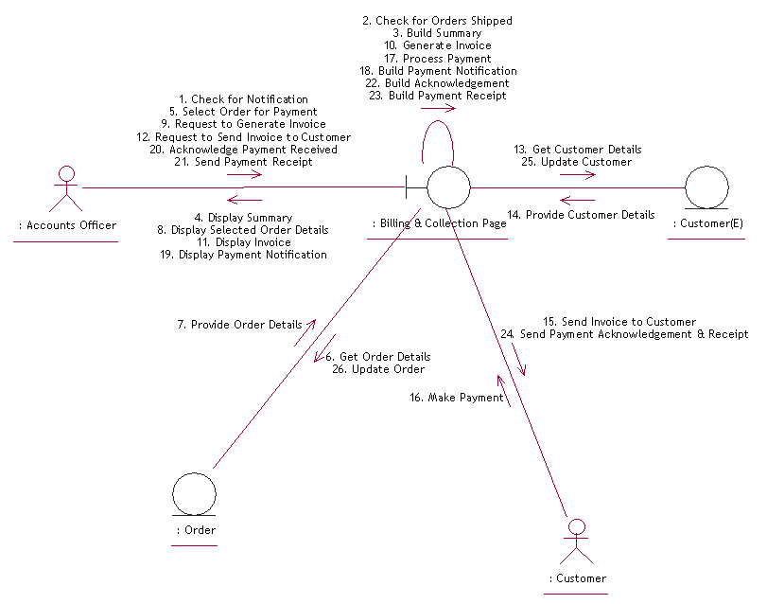
(4 Marks)
Use Case Description for Billing & Collection

- Use Case Name: Billing & Collection
- Primary Actor: Accounts Officer
- Secondary Actor: Customer
- Preconditions:
  - The shipment of the order to the customer has been made.
- Standard Flow of Events:
  - The accounts officer (AO) receives the notification about shipment confirmation from the shipping department along with the work order.
  - The AO reviews the order and logs the details into the billing system.
  - The billing system then generates an invoice for the order.
  - This invoice is reviewed by the AO for correctness.
  - The invoice is then sent to the customer electronically with a request to make payment on or before the payment date.
  - The customer then sends the payment to the AO.
  - The AO then acknowledges the payment received and sends a payment receipt to the customer.
  - The AO then processes the payment made by the customer and updates the order records.
- Post Conditions:
    - The order information of the customer must be updated and payment made status reflected.
Question 4 (20 Marks)

You belong to the Software Engineering team for an Internet-based e-commerce company specializing in online auction, eStraits Pte Ltd. The company is pioneering an object-based implementation of their core services, and has decided to implement using the Java language.

You are involved in the implementation of the Auction business object, and have to implement its code based on the design specification for several use cases. Here we consider the Auction Editing subsystem, by means of which the Auction Administrator prepares a list of items for a given auction (i.e. each item corresponds to an object being auctioned). The subsystem maintains this list, allowing modifications of the item order, so an interesting and compelling sequence can be built. The Administrator uses a graphical user interface to manipulate the auction data. In particular, the list of items is implemented as a list box, each item represented by a string (showing the name of the item).

Figure 1 (on the next page) shows a sequence diagram for the Add Auction Item use case, which is used to create a new item from the user interface, and enter it in the sequence; figure 2 (on page 8) shows the sequence diagram for the Move Auction Item use case, which allows the user to drag-and-drop an item to a different position within the sequence. In figure 3 (on page 8), you are provided with a skeleton for the Auction class.

Write the complete code of the Auction class using the information provided in figures 1, 2 and 3. You only need to provide code to implement the interaction diagrams given, and need not worry about the behaviour of external classes. You may assume that, after execution of the Auction constructor, the items array is always instantiated.

Figure 1: Sequence Diagram for Add Auction Item use case

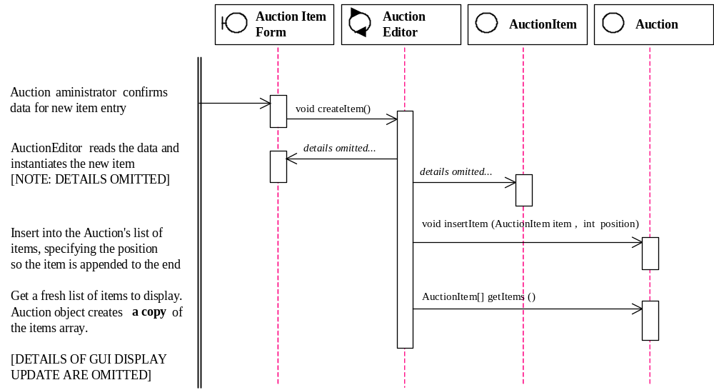

Figure 2: Sequence Diagram for Move Auction Item use case

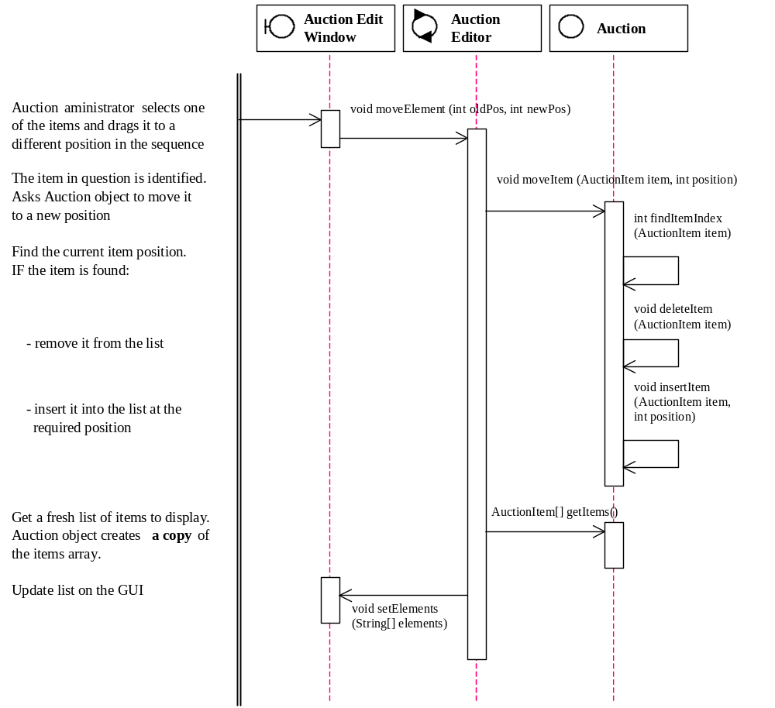

Figure 3: Incomplete skeleton code for the Class AUCTION.

public class Auction {

private int id;
private DatabaseManager dbManager;
private AuctionItem[] items;

public Auction (int id; DatabaseManager dbManager) {
this.id = id;
this.dbManager = dbManager;
items = dbManager.getAuctionItems (id);
}

[...]

}

Question 5 (6 Marks)

You are a software developer of a project team building a Cloud-based system. As you are the only team member familiar with Cloud Computing, your project manager has tasked you with capturing the following key design concerns and associated guidelines:
Design Concern 1:
The Cloud Computing platform (ie: middleware) supplies a software driver that provides a number of object-oriented interfaces (ie: APIs). The software driver allows the programmer to access many Cloud-based services without the need to know the intricacies of Cloud Computing. Unfortunately the choice of the right interface to use is less than obvious – it is commonplace for the designers, who are designing different parts of the system, to pick conflicting interfaces that result in incompatibilities. You decide to devise a guideline that selects the interface based on the part of the system being designed.
Design Concern 2:
The Cloud-based system is highly concurrent. It comprises several software processes and software threads. The composition of the processes and threads is expected to confuse the designers, resulting in typical concurrency problems such as deadlocks and starvations. You decide to capture in detail (as guidelines for common understanding) two aspects of concurrency: (1) the composition of process instances and thread instances; and (2) the interaction between these process instances and thread instances.
The project’s software architect is a firm believer in formally specifying design concerns and their guidelines using UML diagrams. She insists on using the following “4+1” View Model of Software Architecture as the framework to categorize these UML diagrams. She accepts only the following types of UML diagrams: Class, Object, Component, Deployment, Use Case, Collaboration, Sequence, State and Activity.
Logical View
Development View
Process View
Physical View
Scenarios
For each of the design concerns and associated guidelines above:
- Select the appropriate UML diagram(s) (you are not required to draw any UML diagrams). Justify your choice.
- Categorize the selected UML diagram(s) using the “4+1” View Model.
Question 6 (Total: 10 Marks)

The Microsoft Foundation Class (MFC) library is a reusable framework for developing object-oriented Windows applications. You are a software architect tasked with devising the appropriate strategies to perform analysis to design transition for a gaming application to be implemented using the MFC library. You have decided to adopt the Java coding style for class diagrams.

Figure 4 on page 11 illustrates a general transition strategy for MFC version 1.0. In particular, an Application object of class CWinApp associates with a Frame Window object of class CFrameWnd. The Application object holds references to entity objects stored in main memory. Two important design choices are as follows:

- CFrameWnd.onPaint() is to be overridden by the application subclass to draw the application-specific content.
- CWinApp.initInstance() is to be overridden by the application subclass to perform the application-specific initialization.

Figure 5 on page 12 illustrates the static view (in the form of a class diagram) of a use case for your gaming application. Class GameBoard is the main display. Class GameController houses the gaming logic. Class Gamer keeps the information of a player. Class Move records a game move made by a player.

Answer the following questions:

- Given the general transition strategy in figure 4, produce the corresponding specific design for the static view given in figure 5 (you are expected to produce a class diagram).
(4 Marks)

- Translate your design (ie: class diagram) in part (a) into skeletal classes (including class declarations with attributes and method signatures) in the Java programming language. Your skeletal code should focus on showing only the following aspects:
  - Inheritance.
  - Establishing and representing the following:
    - Unidirectional or bidirectional associations.
    - Multiplicity of associations.
Notes:
  - You may assume that equivalent Java classes for MFC are provided.
  - You are not required to provide any implementation code for the operations/methods.
(6 Marks)
Figure 4: An Analysis to Design Transition Strategy for MFC version 1.0
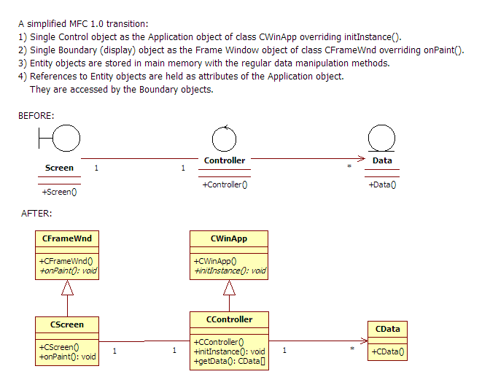
Figure 5: The Static View of a Use Case of a Gaming Application
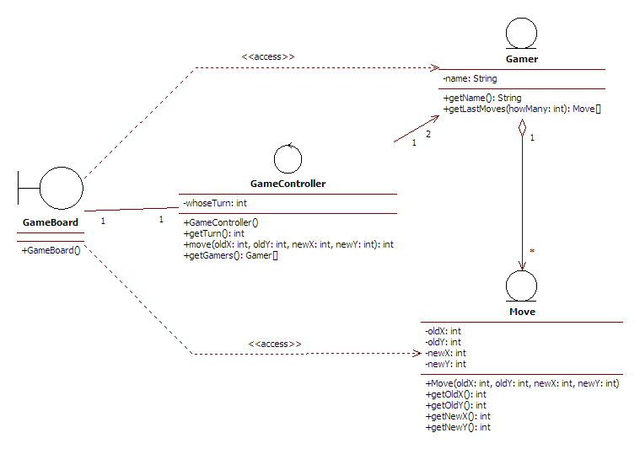

Question 7 (Total: 30 Marks)

You are part of a team developing an Internet Email client program, which has been modeled using UML under RUP. The client is now being implemented using Java and its AWT graphical user interface API. You are working on the use case Select Contact, in which the user can select a recipient for his email, by selecting it from a list in a dialog box (the Contact Select Box), as shown in the mock-up screen in figure 6 (on page 14). The User can type some text in the Text Field of this dialog and, as a result, the system shows in a List Box all the entries in the user’s address book whose name or surname begin with the string typed. The user can then double-click on one of the entries, and the system adds the selected contact to the list of recipients.

- Figure 7 (on page 14) shows the Analysis stage class diagram for this use case. The Contact Select Box (created by the Contact Manager) uses the Contact List object in order to search the list of available Contacts, and identify a set of selectableContacts with which it populates the list box. When the user finally selects an item from the list box, the corresponding Contact object is passed to the setSelected() method of Contact Manager (all subsequent processing by the application is outside the scope of this question).
Figure 8 (on page 15) presents the Design class diagram derived from the above analysis model, specific to the Java/AWT environment. Write an appraisal of this design, which should detail:
- The reasons for introducing any new objects at design stage, and the role of these new objects.
- The reasons behind any changes in the relationships, or introduction of new relationships between objects.
- The interdependencies between objects, e.g. at creation time, and the need to establish relationships between them.
- The reasons for introducing new methods in the objects.
- The use of existing library classes.
- The use of any design patterns or practices you can identify, if any.
You are advised to make your points clear and concise; your answer must be comprehensive, but not necessarily very lengthy.
(15 Marks)

- Using the objects represented in the diagram in figure 8, sequence diagrams have been produced (see figures 9 and 10 on pages 16 and 17) to show how the list box is populated when the user types some text, and how the Contact is set when the corresponding item is double-clicked in the list box. Using these diagrams, produce the complete Java code for class ContactSelector.
(15 Marks)
Figure 6: The Contact Select Box

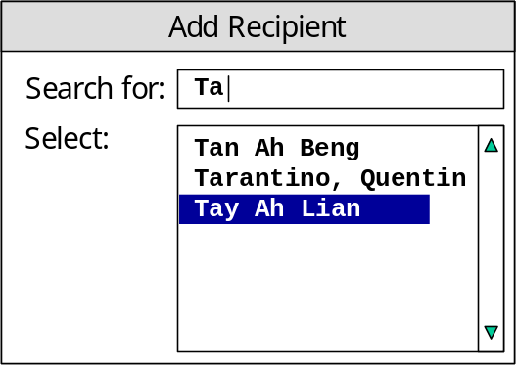

Figure 7: Analysis Class Diagram for the Select Contact use case

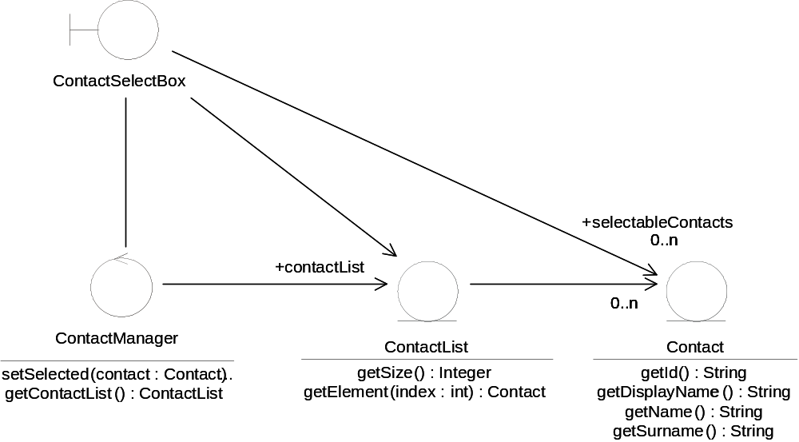
Figure 8: Design class diagram for the Select Contact use case

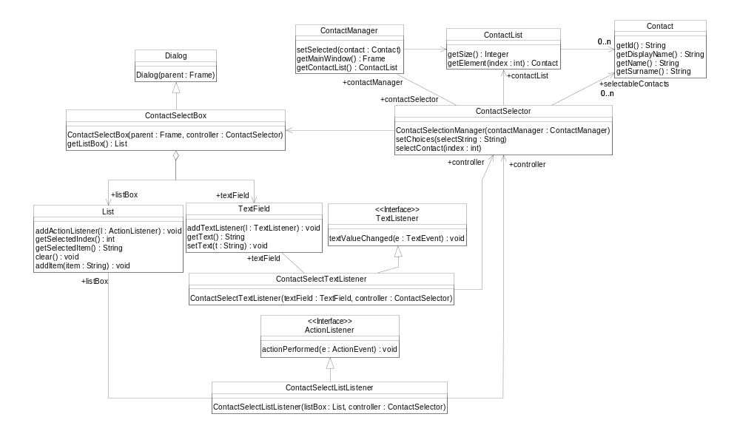
Figure 9: Sequence diagram for the Select Contact use case, showing how the List is populated

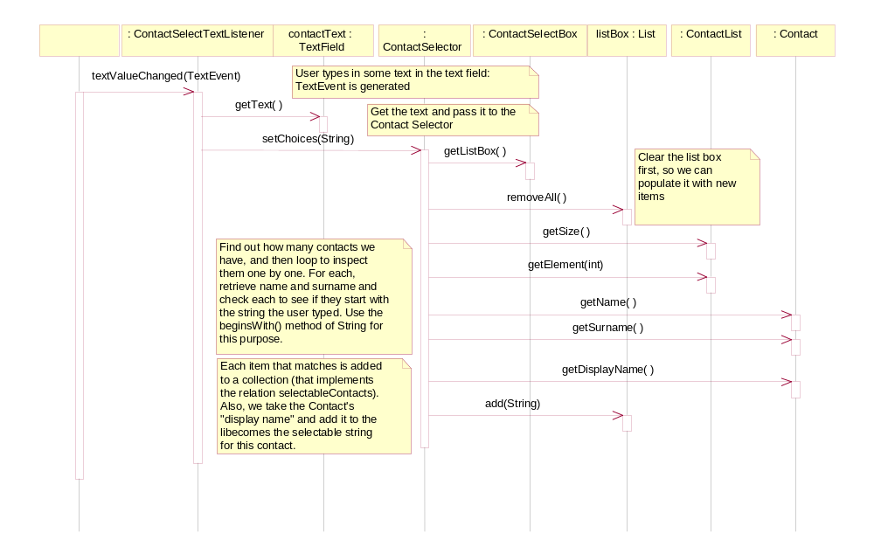
Figure 10: Sequence diagram for the Select Contact use case, showing how a Contact is selected

